Installing SOLIDWORKS

Written by: Alexander Kofman – Fall 2021

You do not have to connect to any VPNs for this process.

1. Navigate to the UW-Madison Campus Software Library at <https://software.wisc.edu/>

If you see this screen, click “Login To The Campus Software Library”

1. Select UW-Madison from the list.

1. Select SolidWorks from the list.

1. Make sure your wisc email is correct in the box, then click on SolidWorks 2021 at the bottom to download the installer. **Do not close this web page yet!**

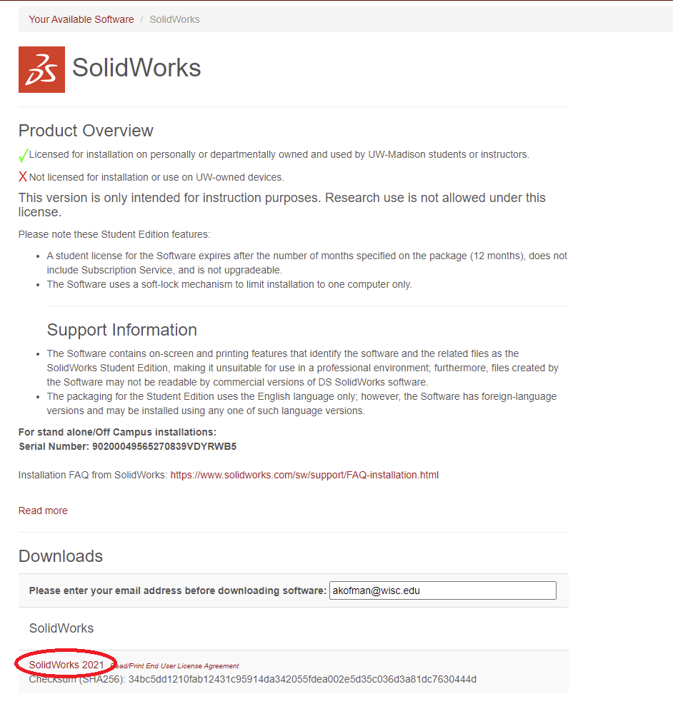

1. Run SolidWorksSetup.exe

1. Unzip the files.

1. You should see a screen that looks like this. You don’t have to restart your computer if you don’t want to.

1. Select “Install on this computer”

1. If the serial number does not auto-populate, copy it down from the download screen shown in Step 4. Don’t check any other boxes, the university license is all covered under the SOLIDWORKS option. You’ll have the option to install these add-ons later in the process.

1. You may see this screen if you have SOLIDWORKS currently installed. Choose “Upgrade” to make the process go faster. If you are having serious problems with your installation, choose “create a new installation” for a clean reinstall.

1. Select the products you will want to install along with the base SOLIDWORKS. You can always re-run this installer to add more products. We recommend the following:

* Solidworks
* eDrawings
* Solidworks File Utilities
* Solidworks Simulation
* Solidworks Motion
* Solidworks

If you plan on creating renderings, it will also be useful to install Solidworks Visualize.

1. Accept the terms of the license agreement and click Download and Install!